Aazhoomog Community Center

**FREE Food Distribution**

**Family Pathways & East Central Energy**

COVID food Assistance P

**Open to all households that are in need!**

**September 15th**

1 PM – 3 PM

**Pine Technical &**

**Community College**

**Please enter and exit**

**on 8th Ave SE**

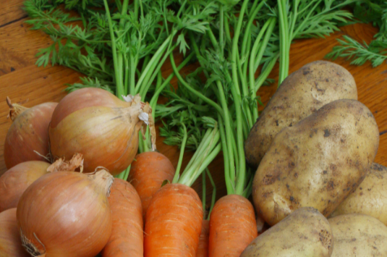

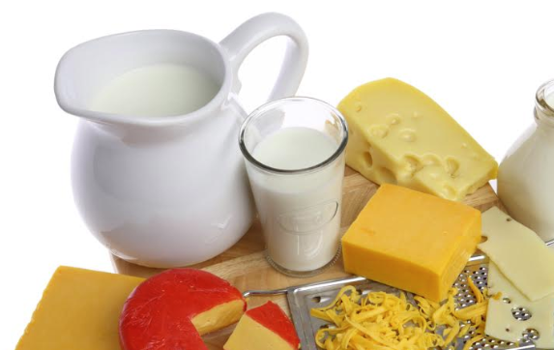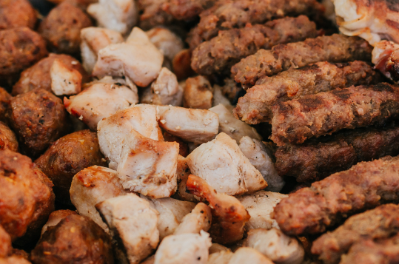

**Ech household will receive:**

**1 box of produce**

**1 box of mixed dairy**

**1 box of meat**

**(chicken & pork)**

**Also Available**:

**Pine County Public Health Mobile Clinic**

**Catholic Charities Senior Dining Meals**

Informatio

